Name :Suganth K V
Reg No 192512108
Code :ECA-5610
Course :ADVANCED WIRELESS
COMMUNICATION SYSTEM
Exp no 01

Simulation and Comparative Analysis of FDMA, TDMA and CDMA: Resource Allocation, User Capacity and Mobile-Generation Context

Aim:
To simulate and compare the basic resource-allocation methods used in FDMA, TDMA and CDMA, and examine how their assumed user capacity and interference behaviour differ.

Program code:(OBJECTIVE 1&2):
>> % Comparison of FDMA, TDMA and CDMA
% Simplified illustrative model; not a full cellular-network simulation. clear; clc; close all;
% Illustrative system parameters
totalBandwidthHz = 1e6; % Total bandwidth: 1 MHz fdmaChannelHz = 200e3; % FDMA channel width: 200 kHz tdmaSlots = 8; % Number of TDMA slots per frame processingGain = 64; % CDMA processing gain targetSIRdB = 7; % Minimum acceptable CDMA SIR
% Capacity estimates under the stated assumptions fdmaUsers = floor(totalBandwidthHz / fdmaChannelHz); tdmaUsers = tdmaSlots;
targetSIR = 10^(targetSIRdB / 10);
cdmaUsers = floor(1 + processingGain / targetSIR);

fprintf('Illustrative maximum supported users\n'); fprintf('FDMA: %d users\n', fdmaUsers); fprintf('TDMA: %d users\n', tdmaUsers);
fprintf('CDMA: %d users at a target SIR of %.1f dB\n\n', ... cdmaUsers, targetSIRdB);
% CDMA SIR as the number of simultaneous users increases K = 2:30;
sirLinear = processingGain ./ (K - 1); sirDb = 10 * log10(sirLinear);
% Display a comparison table
method = ["FDMA"; "TDMA"; "CDMA"];
supportedUsers = [fdmaUsers; tdmaUsers; cdmaUsers]; results = table(method, supportedUsers);
disp(results);

% Plot estimated user capacity figure;
bar(categorical(method), supportedUsers); ylabel('Illustrative maximum supported simultaneous users'); title('FDMA, TDMA and CDMA: Capacity Estimate');
grid on;
% Plot estimated CDMA SIR as users are added figure;
plot(K, sirDb, 'o-', 'LineWidth', 1.5); hold on;
yline(targetSIRdB, '--r', 'Target SIR'); xlabel('Number of simultaneous CDMA users (K)'); ylabel('Estimated SIR (dB)');
title('Estimated CDMA SIR versus Number of Users'); grid on;
hold off
;

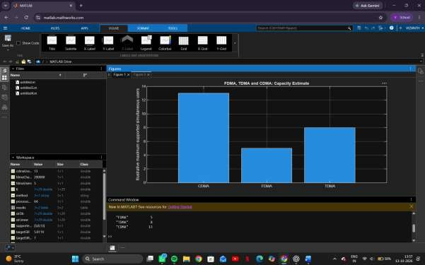
OBJECTIVE 1: To estimate and compare the illustrative number of users supported by FDMA, TDMA and CDMA using the specified system parameters.

OBJECETIVE 2: To analyze how the estimated CDMA signal-to-interference ratichangeas the number of simultaneous users increases
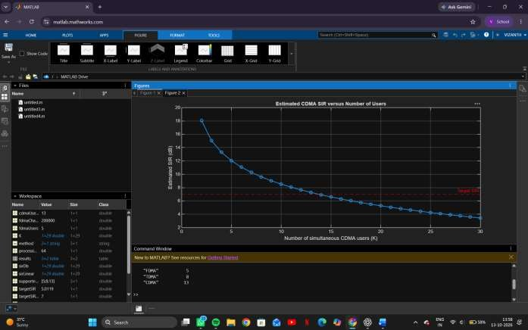

Objective 3: Mobile-generation comparison:
To relate representative multiple-access techniques to the evolution of mobile communication systems from 1G to 5G.

PROGRAM CODE:
generation = ["1G"; "2G"; "2G"; "3G"; "4G"; "5G"];
system = ["AMPS"; "GSM"; "IS-95"; "UMTS"; "LTE"; "5G NR"];
accessMethod = ["FDMA"; "TDMA"; "CDMA"; "WCDMA"; "OFDMA"; "OFDMA-
based"];
keyIdea = ["Separate frequency channels"; ... "Separate time slots"; ...
"Code-based user separation"; ... "Wideband code-based access"; ... "Orthogonal frequency resources"; ... "Flexible OFDM-based radio access"];
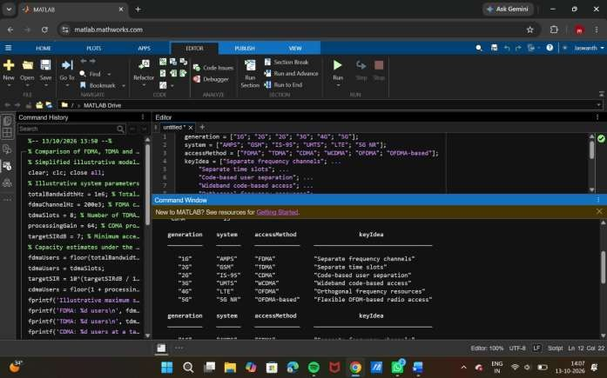

Objective 4: Resource-allocation diagrams:
To visualize how FDMA, TDMA and CDMA assign frequency, time and code resources to multiple users.

CODE:
figure; tiledlayout(1,3);

% FDMA: users occupy different frequency channels nexttile;
hold on;
colors = lines(4); for u = 1:4
rectangle('Position',[0, u-1, 1, 0.8], ...
'FaceColor',colors(u,:), 'EdgeColor','k');
text(0.5, u-0.6, sprintf('User %d',u), ... 'HorizontalAlignment','center');
end
xlim([0 1]); ylim([0 4]); xlabel('Time'); ylabel('Frequency channel'); title('FDMA'); set(gca,'YTick',[]);
hold off;

% TDMA: users occupy different time slots on one frequency channel nexttile;
hold on; for u = 1:4
rectangle('Position',[u-1, 0, 0.8, 1], ...
'FaceColor',colors(u,:), 'EdgeColor','k');
text(u-0.6, 0.5, sprintf('User %d',u), ... 'HorizontalAlignment','center');
end
xlim([0 4]); ylim([0 1]); xlabel('Time slot'); ylabel('Frequency channel'); title('TDMA'); set(gca,'YTick',[]);
hold off;

% CDMA: users share the same time and frequency band using different codes

nexttile; hold on; for u = 1:4
rectangle('Position',[0, 0, 1, 1], ...
'FaceColor',colors(u,:), 'FaceAlpha',0.22, ...
'EdgeColor',colors(u,:), 'LineWidth',1.5);
end
text(0.5, 0.62, 'Users 1-4 share', 'HorizontalAlignment','center'); text(0.5, 0.40, 'band; different codes', 'HorizontalAlignment','center'); xlim([0 1]); ylim([0 1]);
xlabel('Time'); ylabel('Frequency band'); title('CDMA'); set(gca,'YTick',[]);
hold off;

sgtitle('Conceptual Time-Frequency Resource Allocation');

CODE:
